ANTI - BULLYING POLICY

Approved by: | Governing Body
Approved at Full Governing Body on: | 14th May 2026
Review date: | 2026
Next Review due by: | Oct 2026 – review in line with KCSIE and any updates based on this
SLT Lead: | Assistant Headteacher- Safeguarding

Contents
Contents 1
General statement 2
Definition 2
Objectives 2
Bullying can be: 3
Cyber-bullying 3
Responding to bullying: 3
Roles and responsibilities: 4
Monitoring and review 5
Appendix 1 6
Appendix 2 (ref. The E-Safety Policy) 7
Appendix 3 8
Appendix 4: Student Reporting Bullying 9
Appendix 5: Staff Reporting Bullying 10
Appendix 6: 11

General statement

The Clere School believes that every student and member of staff has the right to be happy and feel safe at school. The school is committed to safeguarding all members of the school community, both students and adults and we expect all staff and volunteers to share this commitment, which is integral to the school ethos and values. We strive to create a culture based on our core values of Community, Integrity and Respect. Students must feel safe and respected if they are learn effectively.

No student or adult deserves to be bullied and bullying of any kind will not be tolerated. Students are constantly encouraged to confide in someone, no matter who and understand explicitly that bullying is not something they have to endure and has no part to play in The Clere School.

Definition

“The repetitive, intentional hurting of one person or group by another person or group, where the relationship involves an imbalance of power. It can be physical, emotional, verbal or psychological.

Bullying can take many forms (for instance, cyber-bullying via text messages or the internet), and is often motivated by prejudice against particular groups, for example on grounds of race, religion, gender, sexual orientation, or because a student is adopted or has caring responsibilities. It might be motivated by actual differences between students, or perceived differences.

A person is bullied when he or she has difficulty defending himself or herself and where there is an imbalance of power or strength. (Olweus, 1999)

Aim

Our aim is to provide an environment where all students and staff feel safe. We recognise that all forms of bullying, especially if left unaddressed, can have a devastating effect on individuals; it can create a barrier to learning and serious consequences for mental wellbeing. By effectively preventing and tackling bullying, our school aims to create a safe environment where students are able to learn and fulfil their potential. We adhere to the 10 key principles outlined by the Anti-bullying Alliance (appendix 3).

Objectives

- To understand what bullying is;

- To recognise and report any kind bullying;

- To understand the school’s response to a bullying report;

- To know where to seek help and support (both in and out of school);

- To follow the policy guidelines if bullying is suspected.

Bullying can be:

Emotional | Being unfriendly, excluding, tormenting (e.g. hiding books, threatening gestures) or being forced to do things;
Physical | Pushing, kicking, hitting, spitting, punching, money or property taken or damaged. Any use of violence.
Verbal | Name- calling, sarcasm, spreading rumours, teasing
Cyber | All areas of internet such as email and internet chat room misuse, mobile threats by text messaging and phone calls, misuse of associated technology, i.e. camera and video facilities
Racist | Racial taunts, graffiti, gestures;
Sexual | Unwanted physical contact or sexually abusive comments;
Homphobic/Transphobic | Because of or focusing on sexuality;
Indirect | Including the exploitation of individuals

Other vulnerable groups include children looked after, traveller groups, children with disability or ability, children with SEND, children from ethnic minorities and/or religious groups.

Cyber-bullying

Widespread access to technology provides a medium for ‘virtual’ bullying, which can occur in or outside school. Cyber-bullying is a different form of bullying which can happen 24/7, with a potentially bigger audience, and more accessories as people forward on content at a click. (DFE Dec 2011).

Responding to bullying:

- It is likely, if appropriate, that the following steps will be taken when dealing with all incidents of bullying reported to the school:

- If bullying is suspected or reported, the incident will be dealt with immediately by the member of staff who has been approached or witnessed the concern.

- The school will provide appropriate support for the person being bullied – making sure they are not at risk of immediate harm and will involve them in any decision making, as appropriate.

- Members of the Pastoral Team will interview all parties involved.

- The Designated Safeguarding Leader (DSL) will be informed of all bullying issues where there are safeguarding concerns.
- The Current Designated Safeguarding Lead (DSL) Rebecca Vaughan Assistant Headteacher.

- The school will speak with and inform other staff members, where appropriate.

- The school will ensure parents/carers are kept informed about the concern and

- action taken, as appropriate and in line with child protection and confidentially policies.

- Support and if appropriate, sanctions will be implemented as appropriate

- If necessary, other agencies may be consulted or involved, such as the police, if

- a criminal offence has been committed, or other local services including early help or children’s social care, if a child is felt to be at risk of significant harm.

- Where the bullying of or by students takes place off school site or outside of normal school hours (including cyberbullying), the school will liaise with parents, outside agencies (eg police), other schools if necessary, to ensure that the concern is fully investigated.

- Appropriate action will be taken, including providing support and implementing sanctions in school in accordance with this policy and the school’s behaviour policy.

- A clear and precise account of bullying incidents will be recorded by the school

- Students will be offered the opportunity to meet with a wellbeing mentor as a means of supporting the individual

- If required, students will be given an opportunity to receive the Kidscape ‘Bullying

- Intervention Training (B.I.T). In very serious cases the school will refer the victim to ZAP (an intensive course run by KIDSCAPE);

Restorative approaches to resolve issues are at the heart of the school’s work.

It is essential that individuals accept responsibility for their behaviour and reflect on the impact that the behaviour has on others. However, sanctions are severe for those repeated offenders who do not comply with advice, guidance, support and intervention. Such sanctions include periods of exclusion and subsequent intervention from the Head teacher and governing body;

- The police will be involved as and when deemed appropriate;

- Each case will be evaluated and monitored to ensure repeated incidents of bullying do not take place.

Roles and responsibilities:

- The Head teacher has overall responsibility for the policy and its implementation.

- The DSL is responsible for linking the policy to The School Development Plan and ensuring it is implemented across the whole school, coordinating and training the student Anti-Bullying Ambassadors, analysing data, and liaising with outside agencies.

- The Senior Leadership Team is responsible for implementing the policy

- The Year Team and pastoral staff are involved in any initial investigations. They will interview the student experiencing bullying, alleged bully/bullies and any witnesses and collect statements of evidence to inform the decision-making process. In agreement with a member of the Senior Leadership Team, they will contact the parents of those involved and prescribe the course of action and report the incident, with resolution on the School’s tracking system.

- Tutors will be involved at all levels and will monitor progress daily.

Monitoring and review

- Students report bullying incidents in person and/or through Safeguardme@clere.school or Online MSFORM.
- Staff report on the Staff MSFORM and CPOMS

- Data is analysed regularly by the AHT responsible for anti-bullying
Discriminatory incidents reported and analysed on CPOMS and Edulink

- Student evaluations (completed at end of incident);

- Time bonded reviews by the year team

- Frequent support and guidance from DSL team / student support services including the tutor;

- Regular feedback from students;

- Wellbeing / safeguarding surveys;

- School Council

- Assemblies;

- DSL/Year Leader Safeguarding meetings

- School Safeguarding Team

- Tracking of internal and external exclusions.

We endeavour to ensure that:

- students are acutely aware of different forms of bullying and actively try to prevent it from occurring;

- the school has an active and highly effective approach to preventing, identifying and tackling bullying;

- students are provided with as many different forms of ‘telling someone’ as possible. peer mentors, wellbeing leaders, prefects, pastoral Support team, ;

- key members of the wellbeing leadership team are trained to support possible students

- all groups of students feel safe at school all times;

- students understand very clearly what constitutes unsafe situations and are highly aware of how to keep themselves and others safe.

Policy links, primarily:
- Behaviour Policy
- PSHCE Policy
- SMSC Education Policy
- E- Safety Policy
- Safeguarding: Child protection Policy
- Attendance Policy
- Equality

- Health and Safety

Appendix 1

The schools Virtual Learning environment advises students and parents of what to do and where to get support (both in and out of school) if someone they know is being bullied. These pages are reviewed and revised annually and reflect the work undertaken by the staff, The wellbeing leadership team and Student Voice.

Advisory Centre for Education (ACE) | 0300 0115 142  enquiries@ace-ed.org.uk
Children’s Legal Centre | Legal Advice: 0845 345 4345 Child/Family Law Advice Line: 0300 0115 142
KIDSCAPE Parents Helpline | Parent Advice Line: 0300 102 4481  WhatsApp: 07496 682785
Parentline Plus | 0808 800 2222
Childline | 08001111
Kooth | Emergencies: 0800454647  General: 02033989048

Bullying Online

- www.anti-bullyingalliance.org.uk

- www.youngminds.org

- www.kidscape.org.uk

- www.bullying.co.uk

- www.nspcc.org.uk

- www.thinkuknow.co.uk (CEOP)

Appendix 2 (ref. The E-Safety Policy)

The Law

Communications Act 2003 (section 127)

Sending by means of the Internet a message or other matter that is grossly offensive or of an indecent, obscene or menacing character; or sending a false message by means of or persistently making use of the Internet for the purpose of causing annoyance, inconvenience or needless anxiety is guilty of an offence liable, on conviction, to imprisonment.

Malicious Communications Act 1988 (section 1)

This legislation makes it a criminal offence to send an electronic message (e-mail) that conveys indecent, grossly offensive, threatening material or information that is false; or is of an indecent or grossly offensive nature if the purpose was to cause a recipient to suffer distress or anxiety.

Protection from Harassment Act 1997

A person must not pursue a course of conduct, which amounts to harassment of another, and which he/she knows or ought to know amounts to harassment of the other. A person whose course of conduct causes another to fear, on at least two occasions, that violence will be used against him is guilty of an offence if he knows or ought to know that his course of conduct will cause the other so to fear on each of those occasions.

Computer Misuse Act 1990

This legislation makes it a criminal offence to gain unauthorised access to another students area even if you don’t change/delete any information on the area.

Appendix 3

United Against Bullying

Anti-Bullying Charter for Schools

The Clere School has committed to the following principles to prevent and respond to bullying.

10 Key Principles

Our school:

- listens - all students and parents and carers are listened to and influence strategies and approaches to prevent, report and respond to incidents of bullying.

- includes us all - all students, including those with SEND, are included, valued and participate fully in all aspects of school life.

- respects - all school staff are role models to others within the school in how they treat others.

- challenges - all forms of discriminatory language (including disablist language), is challenged and taken seriously

- celebrates difference – difference is actively and visibly celebrated and welcomed across the whole school.

- understands - all school staff, students and parents and carers understand what bullying is and what it isn't.

- believes - all students, including disabled children and those with SEND, and their parents/carers are acknowledged, believed and taken seriously when reporting incidents of bullying.

- reports bullying - all students within the school and their parents/carers understand how to report incidents of bullying.

- takes action - we respond quickly to all incidents of bullying. Students, including disabled students and those with SENd, participate fully in decisions made about them and help to formulate appropriate action to respond to incidents of bullying.

- has clear policies - our school's anti-bullying policy reflects these principles and is embedded within other school policies. They are widely and actively promoted to school staff, students and their parents and carers.


Appendix 4: Student Reporting Bullying
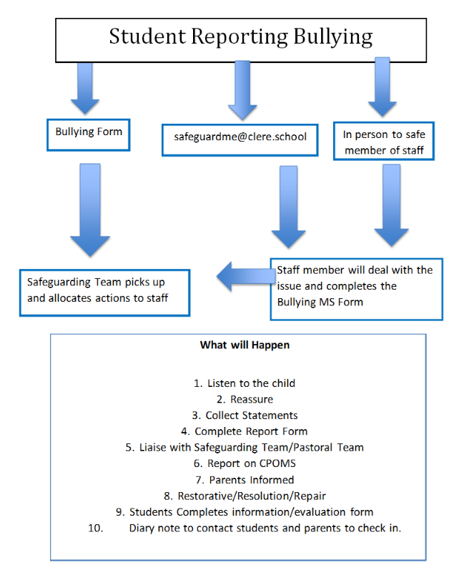

Appendix 5: Staff Reporting Bullying

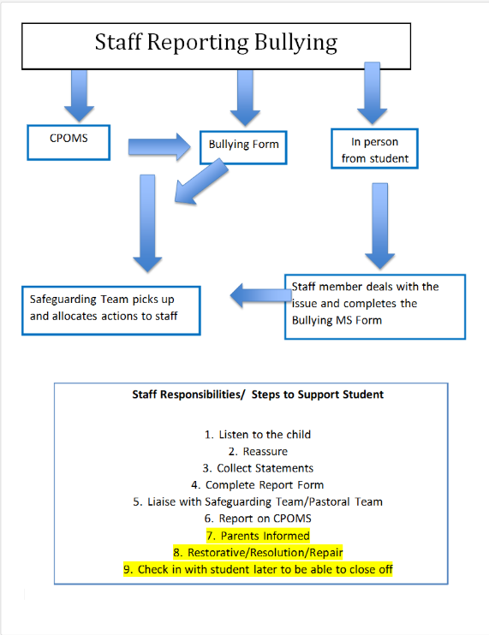

NB: Highlighted is picked up and addressed by the safeguarding team.

Appendix 6:
